.

| **EX NO:2**  **DATE:** | **TO UNDERSTAND HOW DIFFERENT COMPONENTS OF PC ARE CONNECTED TO WORK PROPERLY ASSEMBLING OF SYSTEM COMPONENTS** |
| --- | --- |

**Aim:** To understand different components of pc are connected work properly

**Procedure:**

**Step 1: Procuring Parts**

1. Processor (CPU) 2. Computer Case

3. Optical Drive (DVD RW and SATA capable) 4. Memory (RAM)

5. Power Supply 6. SATA Cables

7. Motherboard (SATA Capable) 8. Processor Fan

9. Case Fan 10. Hard Drive (SATA Capable)

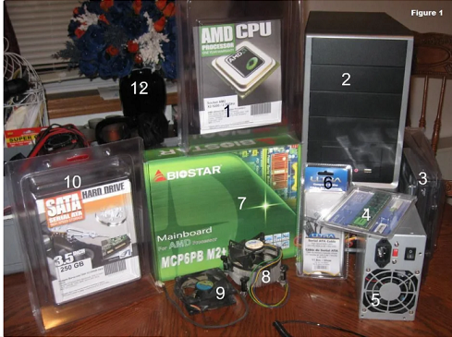

**Step 2: Gather Tools and Supplies**

Gathering the tools you will need for the project:

* Screwdriver Wire cutters and strippers
* Needle-nosed pliers Utility knife
* Small flashlight Adjustable wrench

Small container to hold screws Heat sink compound

* Grounding Strap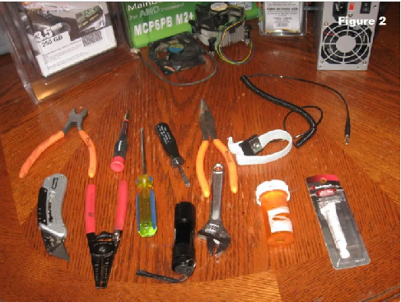

**Step 3: Open the Case**

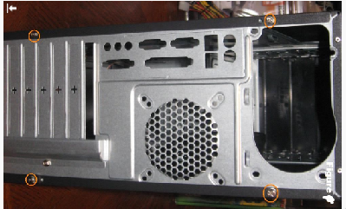

Open the computer case by removing the side panels. Find the screws that hold the side panels in place and remove them

**Step 4: Prepare the Case for Assembly**

* Three things need to be done before assembly begins:
* Remove any parts or packaging materials that may have been shipped inside the case .
* Remove the cover for the optical drive. we will be removing the cover on the highest drive bay to mount our DVD drive
* These should be front panel connections for features such as the power switch, audio jacks and USB ports.

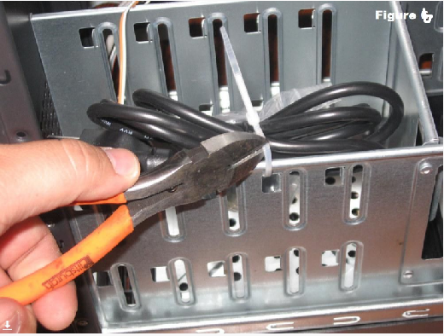

**Step 5: Install Motherboard.**

To install the motherboard we need parts that should have been included with your purchased components:

* I/O Bezel is a trim panel installed in the back of the case that surrounds the interface ports on the motherboard. It should be included with the motherboard.
* Standoffs are installed in the case screw holes to create a riser that separates the case and motherboard.
* Install standoffs in the case. The standoffs screw into the motherboard mounting holes Check the screw hole locations on the motherboard for exact placement.
* Lower the motherboard into the case and align with the I/O bezel.
* Install the screws. It works best to leave the screws loose until all of them have been started and the board is aligned with the bezel.

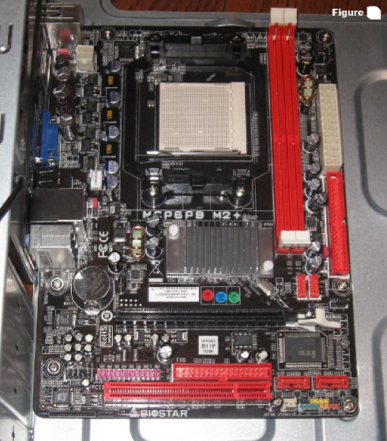

**Step 6: Install Hard Drive**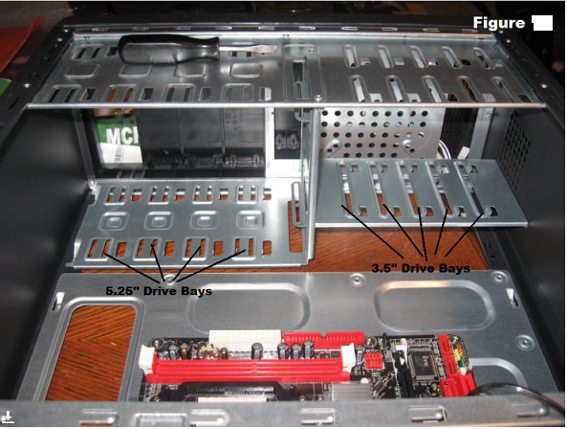

* The hard drive is the device that stores all of your data. It is 3.5" wide and needs to be mounted so that you can gain access to the cable connections on the back
* Find a 3.5" drive bay to install the drive in.
* Slide the drive into place until the screw holes on the sides are lined up with the holes in the case. And Install the screws.

**Step  7: Install Optical Drive**

* The optical drive is 5.25" wide and is installed in the drive bay that we removed the cover from in a previous step. Cable access considerations apply to this drive also.

**To install the drive:**

* Slide the drive into the drive bay until the screw holes are lined up and the front of the drive is flush with the front of the case
* Install the screws.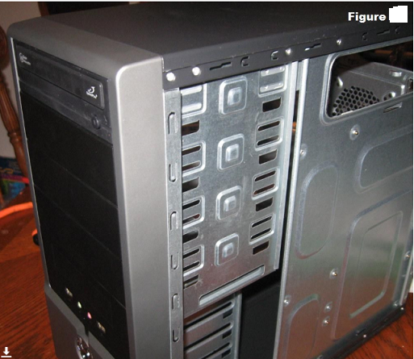

**Step 8: Install the CPU**

* The CPU is the brain of the computer. It is installed on the motherboard in the socket

**To install the CPU:**

* Find the corner marking that designates pin 1 of the CPU , On this AMD brand processor, the corner is marked with an arrow. Consult the manufacturer's documentation for specific information about your processor.
* Lift the small metal rod next to the socket
* Find the corresponding marking on the CPU socket and insert the CPU so that the markings are lined up.
* Push the rod down to lock the processor in place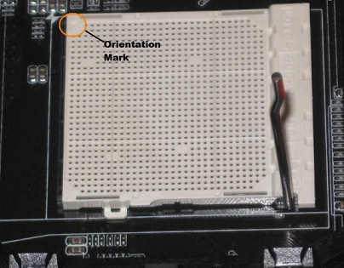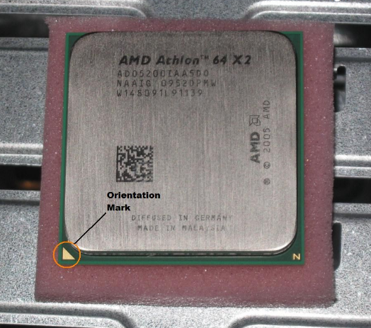

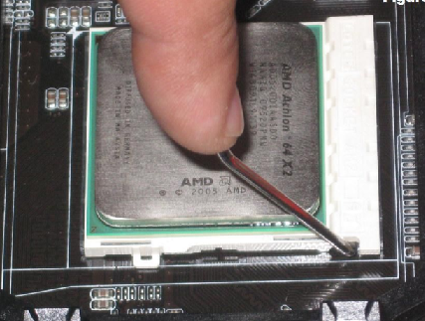

**Step 09: Install RAM**

* The RAM is the temporary memory location that the processor works from. Permanently stored data is pulled from disks and stored in RAM while the processor works with it.
* Set the RAM board in the socket. Check to see that the notch in the board is in the correct location. If it is not, turn it around 180º.
* Press firmly on both ends of the board to set it into the socket.

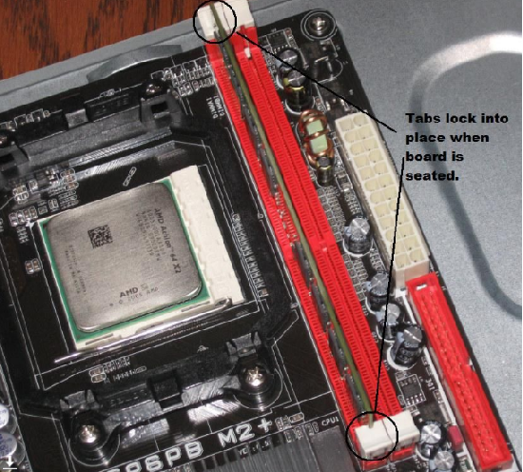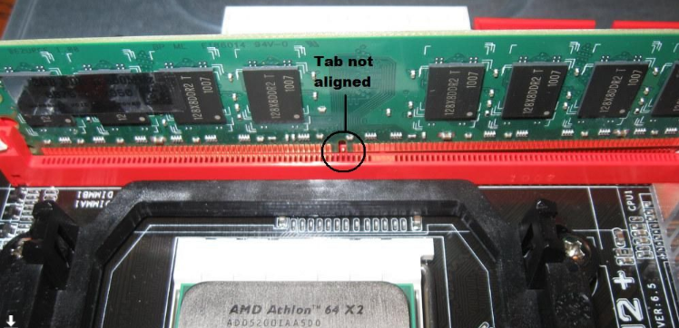

**Step 10: Install the CPU Fan**

* The CPU fan is really a combination of a heat sink and fan together. The unit draws heat away from the CPU.

**To install the fan:**

* Place thermal compound to the CPU following the instructions provided with the compound.
* Set the fan assembly on the CPU with mounting tabs aligned.
* Pull the locking rod down on the fan assembly to lock into place.
* Connect the fan assembly's power connector to the motherboard. Consult the manual to determine proper placement.

**Step 11: Install Case Fan**

* The case fan is usually installed on the back panel of the case.

**To mount the fan:**

* Align the mounting holes by holding the fan to the mounting pad on the inside of the case. The fan needs to be mounted so that it blows air out of the case.
* Insert the screws from the outside of the case and tighten.

**Step 12: Install Power Supply**

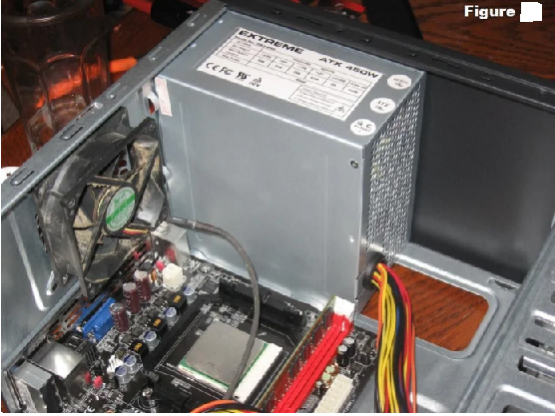

**Step 13: Connect Cables**

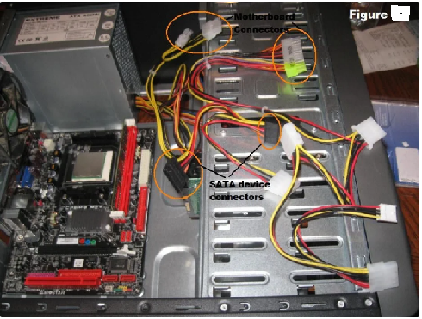

* Every device that has been installed needs power. The power supply connectors are shown. The motherboard has two power connections, and there are two connectors specifically for SATA devices (drives). The other connectors will run fans and other non-SATA devices.
* Data cables connect drives and front panel devices to the motherboard. Please consult the motherboard documentation for the exact placement of connectors.

**Step 14: Wrap-up**

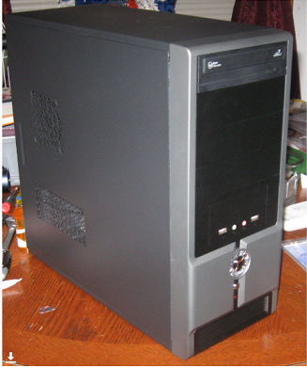

**Result :**Thus the different components of pc are connected to work properly assembling of system components

| **EX NO:3**  **DATE:** | **TO UNDERSTAND HOW DIFFERENT COMPONENTS OF PC ARE CONNECTED TO WORK PROPERLY DISASSEMBLING OF SYSTEM COMPONENTS** |
| --- | --- |

AIM: To Understand How Different Components Of Pc Are Connected To Work Properly Disassembling Of System Components

PROCEDURE:

**Step 1: Unplugging**

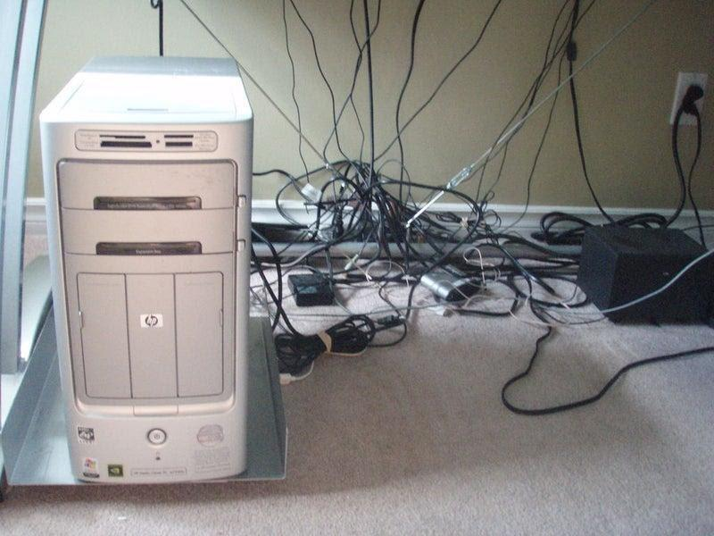

Unplug every cable that's plugged in to your computer. That includes the following cables:Power,USB, Firewire, Mouse, Keyboard, Internet, Ethernet, Modem, AM\FM Antenna, Cable TV

**Step 2: Outer Shell/Casing**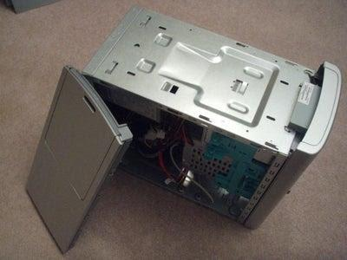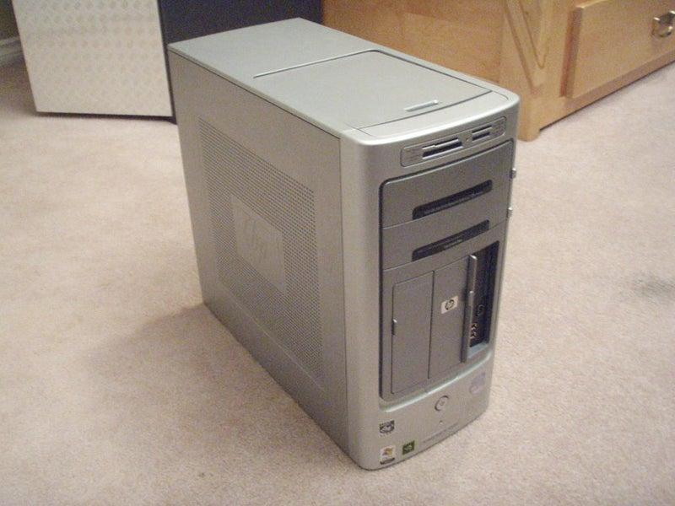

Unscrew the four screws on the back of the computer.Once the screws are removed, you can remove the side panels.

**Step 3: System Fan**

unplug the fan from the motherboard. You can find the plug by following the wire from the fan. It should be labeled"SYS_FAN1". Next, you will have to unscrew the fan from the outside. You should now be able to lift the fan out of the PC.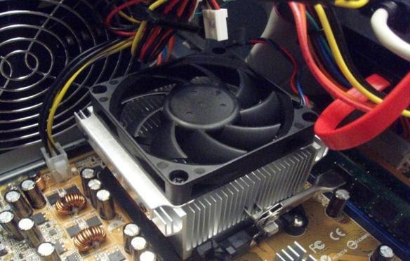

**Step 4: Power Supply**

The power supply supplies power to every component in a computer, unplug every wire coming from the power supply. The list below is everything that I had to disconnect:

* Motherboard (very large connector/plug)
* CD/DVD drive[s] power
* Internal hard drive power
* Portable hard drive slot power

Once everything is unplugged, unscrew the four screws holding the power supply in place, on the back of the computer.

**Step 5: CD/DVD Drive[s]**

The CD/DVD drive is one of the easiest components to remove. First, unplug the ribbon from the back of the drive.

**Step 6: Hard Drive &amp; Portable Hard Drive Slot**

 In order to remove the hard drive, you must remove the portable hard drive slot first.

First de-attach the connector at the back of the slot, and unplug the other end from the motherboard. unplug the SATA cable from the motherboard and the hard drive. The portable hard drive slot is secured the same way the CD/DVD drive is, with a tab. Pull on the tab, then slide the slot out.To remove the hard drive from the side of the slot, unscrew the four screws securing it in place.

**Step 07: Expansion Cards**

Expansion cards are like small upgrades to your computer.

Expansion cards give a computer new capabilities, once installed. Different examples are:Bluetooth,WirelessInternet,Ethernet,TV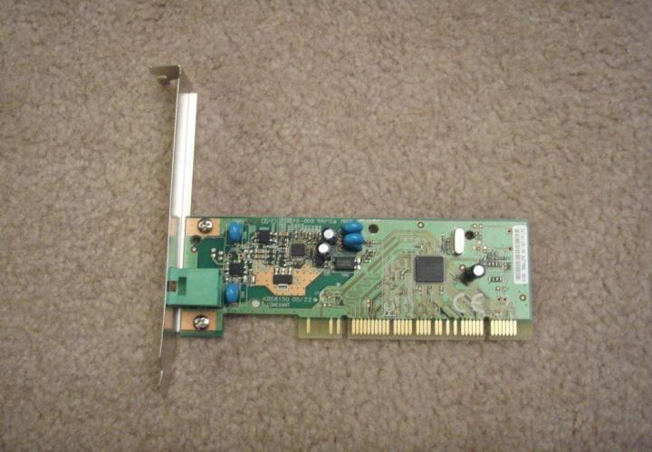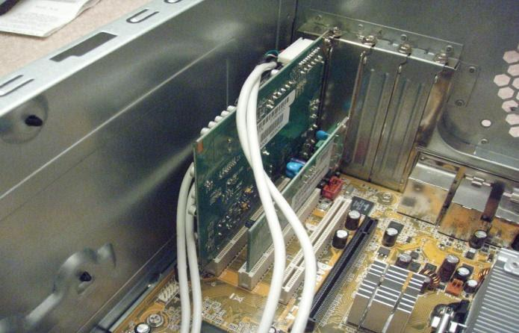

**Step 08: Connectivity Centre Cables**

The connectivity center is the area on the front of the computer where there is many input sections, like usb, firewire, microphone, headphones, video, etc.. I won't remove the whole connectivity center in this step, but I will unplug all the cables coming from it.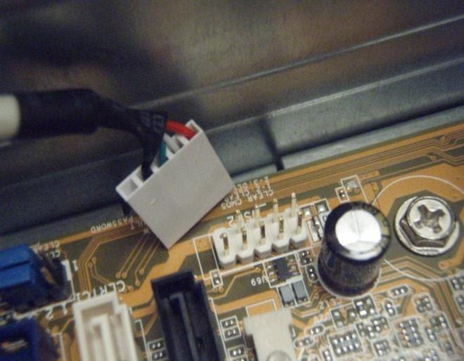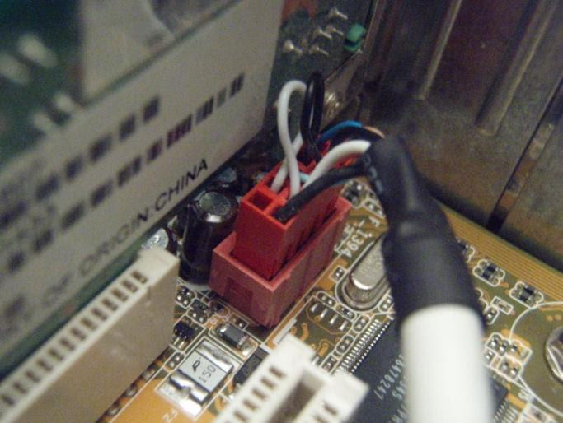

**Step 09: RAM (Random Access Memory)**

RAM you have, the faster your computer runs. Most computers have 4 RAM slots, and two RAM chips.  To remove the RAM, push down on both tabs holding the RAM in place, which are located at both ends of the RAM. Please see the pictures.

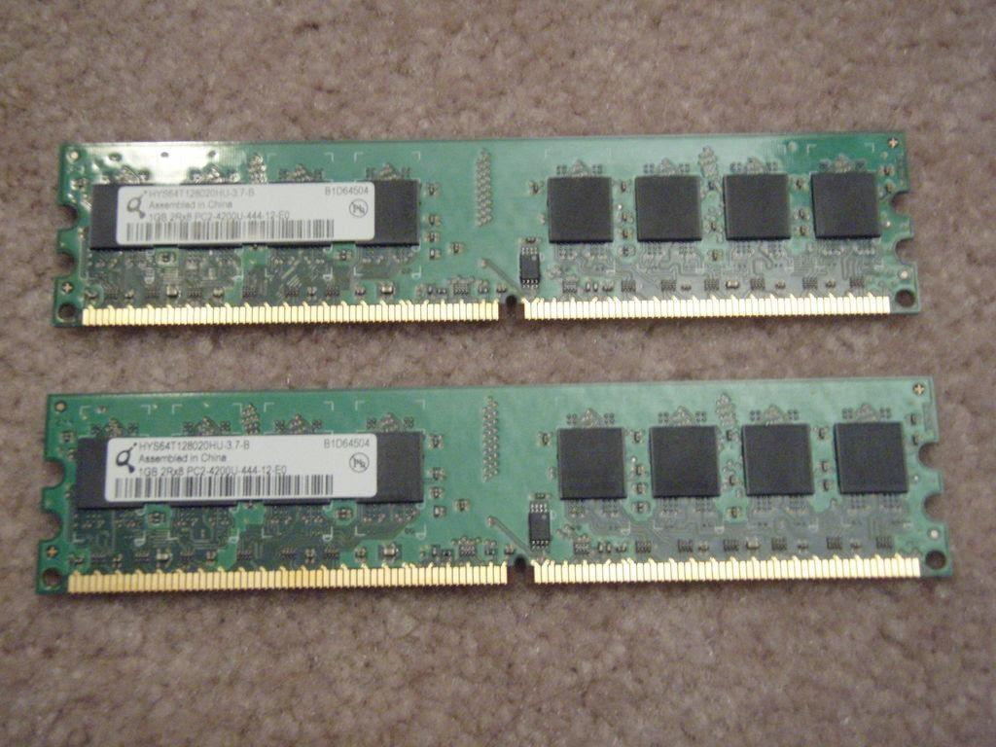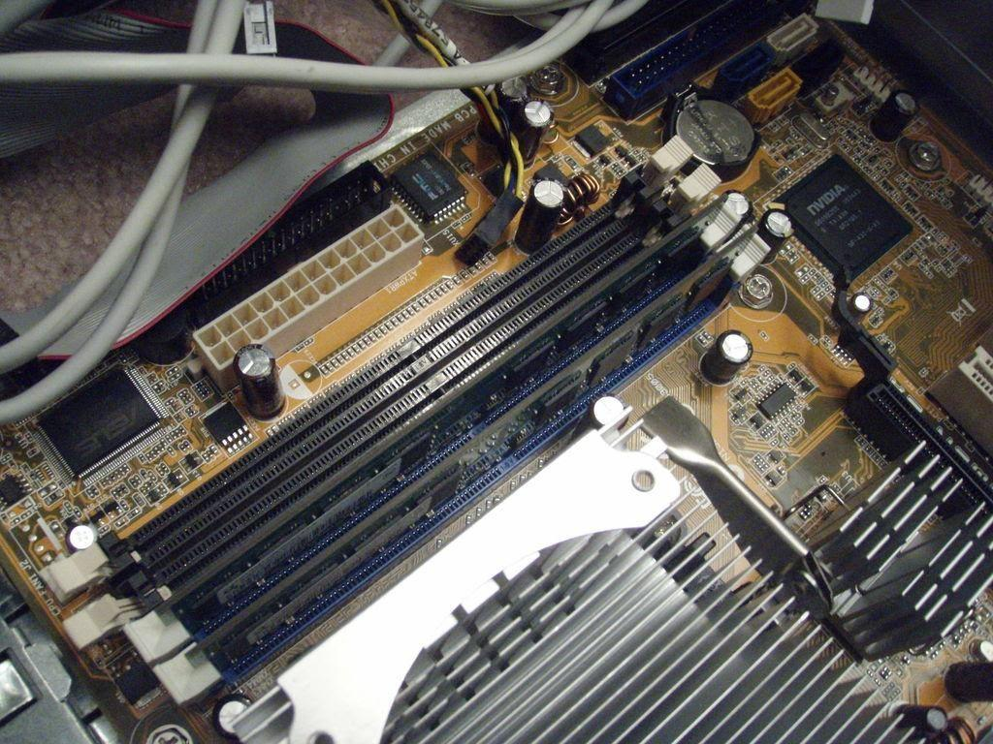

**Step 10: Motherboard**

 The motherboard links every component in the computer together. The CPU, RAM, and expansion cards are attached directly to it, and every other part of the computer is in one way or another attached to it.The motherboard has seven screws holding it to the frame, which are indicated by large white circles around them.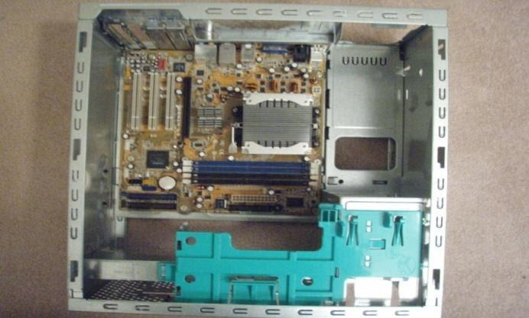

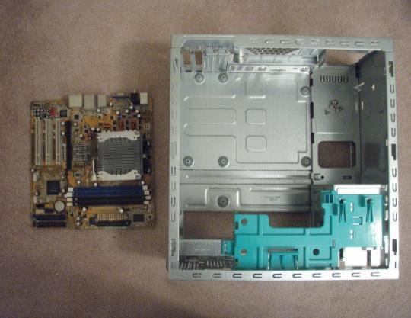

**Step 11: Disassemble a Computer has been done**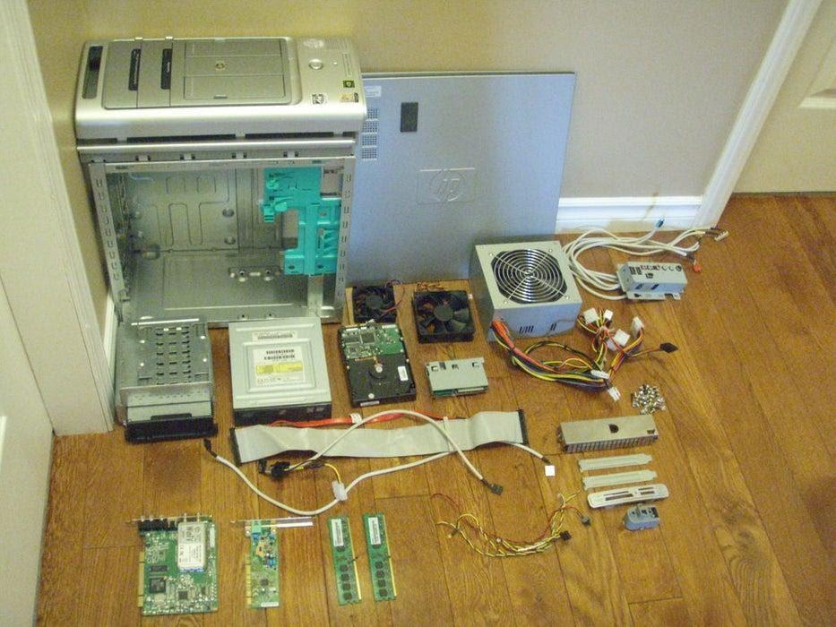

**Result:**Thus the different components of pc are connected to work properly Disassembling of system components